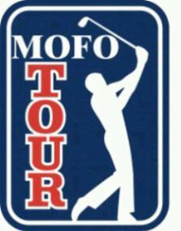
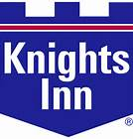
2016
Dear MoFo-ers,

Clean your balls and spit shine your shafts, its MoFo time!

Back with popular demand is the MoFo Cup 2 man scramble. There are 3 Tours, MoFo, KiFe and Shit Show. Secure your partner and submit your team name with down payment by March 19th, 2016. Let us know if you need help finding a partner.

Thanks,
Dan and Jay.

May 27th –May 29th, 2016

PLACE: Brooklea Golf and Country Club.
Midland, Ontario. www.brookeagolf.com

LODGING: Luxurious Knights Inn.
Midland, Ontario. www.knightsinn.ca

TEE TIMES Friday May 27th 730am & 1pm. Hamburger lunch provided between rounds.
Saturday May 28th 11am.
Sunday May 29th 10am.

COST: $350 per player. You can etransfer dan.krisko@telus.com
$250 per player & team names due by March 19th, 2016.
$100 per player due by April 23rd, 2016.
Optional par 3 skins are on! $40 a team paid before Friday’s round.

FORMAT: Friday rounds 1 & 2 are MoFo Cup qualifiers. Teams that do not make the cut play a 1 round qualifier for the KiFe Cup on Saturday. Teams that do not make that cut are flushed into the Sunday Toilet Bowl.
Each Tour will have team champions and names engraved on the cups.
MoFo Cup -4 rounds total score.
KiFe Cup -2 round Saturday/Sunday total score.
Shit Show -1 round Sunday score.

PRIZE MONEY: Depends on the number of teams. This will be decided once field is finalized.
(& POBs)

For more info visit
www.mofogolf.ca

